**Evolve: Tool Support for Architecture Evolution**[**http://www.intrinsarc.com**](http://www.intrinsarc.com)

Andrew McVeigh, Jeff Magee, Jeff Kramer: Imperial College London

Evolve is a toolset built around an ADL which incorporates evolution as an intrinsic architectural concern. The approach integrates structural inheritance and evolution, allowing both to be used in the design phase. The work came out of considering how systems are extended and evolved in a decentralized setting where there is no shared CM infrastructure and where multi-party design authority is the norm.

Evolve incorporates evolution by adding three concepts to a Darwin/ROOM-like ADL.

Resemblance and replacement are used together to allow incremental evolution of a component. A formally specified algorithm describes how replacement rewrites the resemblance graph for each stratum perspective.

Evolve builds on the above concepts to provide a model driven environment which can reuse existing components.

Full hierarchical component support Design using the evolution constructs  
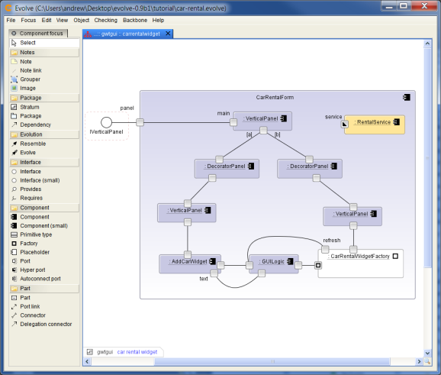 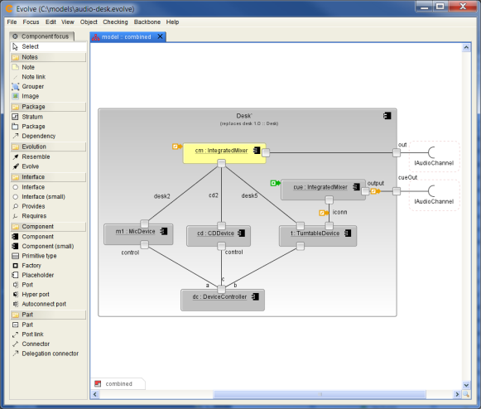

Define and evolve executable state charts Work with standard Java components  
